Lab Session 05
User Interface Construction and Prototyping in Software Development

Objective
The objective of this lab is to introduce students to the concept of User Interface (UI) construction and early-stage software design. Before writing code, developers must first understand how users will interact with the software system. This is achieved by designing wireframes and simple prototypes that represent the structure and navigation of the system.

In modern software development practices, designing the interface before implementation is considered an essential activity. Wireframes help developers visualize the layout of a system, understand the placement of interface components, and ensure that the system provides a clear and user-friendly interaction flow.
Through this lab, students will learn how to design basic interface structures using prototyping tools. The lab also demonstrates how visual planning can reduce development errors, improve communication between development teams, and enhance the overall usability of a system.
This lab focuses on applying software construction principles to create structured and organized user interfaces for a simple software system.

Learning Outcomes
After completing this lab, students will be able to:

- Understand the importance of interface design in software construction
- Describe the concept of wireframes and prototypes
- Design a basic user interface layout for a simple software system
- Identify essential components of an interface such as headers, navigation menus, forms, and content areas
- Use a prototyping tool such as Figma to design interface structures
- Document interface design as part of the software development process

Introduction
Software development is a structured process that involves multiple stages such as requirements analysis, design, construction, testing, and maintenance. During the construction phase, developers transform system designs into working software through coding and integration.

However, before actual coding begins, developers must understand how users will interact with the system. This is where User Interface (UI) design becomes important.

A poorly designed interface can make a software system difficult to use, even if the underlying functionality works correctly. Therefore, software engineers often create wireframes and prototypes before implementation begins.
Wireframes provide a simplified visual representation of the system layout. They show how interface elements such as buttons, forms, images, and menus will be arranged on the screen.

By designing wireframes, developers can:
- Understand system navigation
- Identify required interface components
- Detect usability issues early
- Communicate design ideas with stakeholders

Wireframes are commonly used in the design and construction stages of the Software Development Life Cycle (SDLC). They serve as a blueprint for developers during implementation.

Background Theory

Software Construction
Software construction refers to the process of building working software systems by translating design specifications into executable code.

This phase typically includes:

    - Coding
    - Interface construction
    - Integration of modules
    - Debugging and testing
Although coding is the primary activity in software construction, developers must first design how the system will operate and how users will interact with it.
Therefore, interface planning and design are essential activities before coding begins.

User Interface (UI)
The User Interface is the part of the software system that allows users to interact with the application. It includes visual elements such as:
    - Buttons
    - Forms
    - Text fields
    - Navigation menus
    - Icons

    - Images

An effective user interface should be:

    - Easy to understand
    - Simple to navigate
    - Visually organized
    - Consistent across different pages

Good UI design improves user satisfaction, productivity, and system efficiency.

Wireframes
A wireframe is a simple visual layout of a user interface. It represents the structural design of a screen without focusing on detailed graphics or colors.

Wireframes usually consist of basic shapes such as:

    - Rectangles representing images
    - Lines representing text
    - Boxes representing buttons
    - Placeholder elements representing interface components

Wireframes help designers focus on layout and functionality rather than aesthetics.

Types of Wireframes
Wireframes can be categorized into three types:

Low-Fidelity Wireframes
Low-fidelity wireframes are simple sketches that show the general layout of the interface. They are quick to create and are often used during the early stages of design.

Mid-Fidelity Wireframes
Mid-fidelity wireframes provide more detail than low-fidelity wireframes. They include labels, interface components, and clearer structure.

High-Fidelity Wireframes
High-fidelity wireframes resemble the final design closely. They include detailed layouts and sometimes interactive elements.
In this lab, students will create mid-fidelity wireframes.

Prototyping
A prototype is a working model of a software system used to demonstrate how the system will function.
Prototypes may be:
    - Static (non-interactive)
    - Interactive (allowing navigation between screens)

Prototyping helps developers and stakeholders visualize the system before development begins.

Importance of Wireframing in Software Construction
Wireframing offers several advantages in software development:

Early Visualization
Wireframes allow developers to visualize the structure of the system before writing code.

Improved Communication

Design ideas can be easily communicated to team members and stakeholders.

Reduced Development Errors
By identifying design issues early, developers can avoid costly changes during implementation.

Better User Experience

Wireframes help designers focus on usability and navigation.

Faster Development Process
Clear design documentation allows developers to implement features more efficiently.

Tools for Wireframing and Prototyping
Several tools are available for designing wireframes and prototypes. Common tools include:
- Figma
- Balsamiq
- Adobe XD
- Canva

For this lab, Figma is recommended because it is free, web-based, and easy to use.

Characteristics of a Good User Interface
A well-designed user interface plays an important role in the success of a software system. When users interact with software, they expect the interface to be clear, responsive, and easy to understand. Poor interface design can confuse users and reduce the overall effectiveness of the system.

The following characteristics are commonly found in good user interfaces.

Simplicity
A good interface should be simple and easy to understand. Users should be able to perform tasks without needing complex instructions. Unnecessary elements should be avoided because they can distract users and make the interface difficult to use.

Consistency
Consistency ensures that similar elements behave in the same way across different screens of the application. For example, navigation menus, buttons, and layout structures should appear in similar positions on different pages.
Consistency helps users learn the interface quickly and reduces confusion.

Visibility
Important actions and information should always be visible to users. Users should easily find buttons, menus, and navigation options. Hidden or unclear elements can make the system difficult to use.

Feedback
When users perform an action, the system should provide feedback. For example, when a user clicks a login button, the system should display a message indicating whether the login was successful or not.

Providing feedback improves user confidence and interaction.

EXERCISE

Question 1 – Interface Layout Design
Using Figma, create a simple wireframe layout for any software system of your choice (for example: Online Store, Student Portal, or Library System).
Your interface should include the following components:

- Header section
- Navigation menu
- Main content area
- Footer section
Use shapes and text to represent these components and attach a screenshot of your design in the lab report.

Question 2 – Login Page Interface Design
Using Figma, design a Login Page interface for the same system created in Question
1. Your design should include the following elements:

- Username input field
- Password input field
- Login button
- “Forgot Password” option
- “Sign Up” or “Create Account” option

Arrange these components properly to create a simple and clear login interface. Attach the screenshot of the design in the lab report.

Question 1
Interface Layout Design
Using Figma, create a simple wireframe layout for any software system of your choice (for example: Online Store, Student Portal, or Library System).
Your interface should include the following components:
- Header section
- Navigation menu
- Main content area
- Footer section
Use shapes and text to represent these components and attach a screenshot of your design in the lab report.

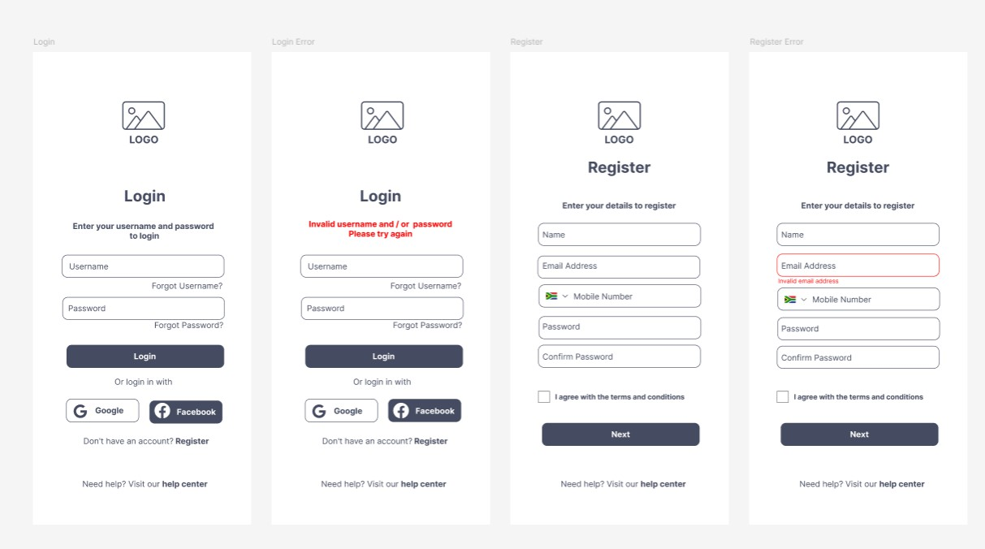

Question 2
Login Page Interface Design
Using Figma, design a Login Page interface
for the same system created in Question 1.
Arrange these components properly to create a simple and clear login interface. Attach the screenshot of the design in the lab report.

